Acknowledgement

The First Nations Youth Strategy Engagement Group proudly acknowledges Aboriginal and Torres Strait Islander peoples as the First Australians and the traditional custodians of our lands, waters and seas. We honour and respect our Elders, past and present, for their teachings of our past. As their descendants, we will carry their learnings and stories with us throughout our individual journeys towards the future.

As young people, we acknowledge the significant roles played by our Elders and ancestors in ensuring our cultures are passed down to our generation and beyond. We accept our responsibilities to continue this caretakership for the benefit of future generations.

As we reflect on our past, and envision our future as young First Nations Queenslanders, we hope to ratify the Path to Treaty and actively seek reconciliation for our communities.

This Acknowledgement was written by collaborative effort of the 2024 members of the First Nations Youth Strategy Engagement Group.
Table of Contents
Acknowledgement 2
Minister’s foreword 4
Young Queenslanders Strategy 5
Young Queenslanders Strategy Action Plan 2024-2026 6
Glossary 7
Participate 8
Responsive government: 8
Educational Programs: 9
Genuine participation, co-design and influence: 9
Participate: Hayes Butler – Youth Strategy Engagement Group 10
Cultivate their futures 11
Careers and Employment 11
Business and Entrepreneurship 12
Education and Training 12
Building Creative and Innovative Generational Futures 13
Cultivate their futures: Lexi Croce 15
Live their best lives 16
Access to information 16
Health and wellbeing 16
Home and community 18
Life Skills 18
Live their best lives: Isaac Campbell 19
Thrive in our communities 21
Science, climate change and world issues 21
Connection 21
Transport 22
Celebrating culture and diversity 22
Thrive in our communities: Charles Hazelton 24
Next steps 25

Minister’s foreword
The Queensland Government is determined to effect real and measurable change to help young people participate fully in their communities, face the future confidently, live their best lives and thrive. This action plan reflects our determination to listen and respond with appropriate measures which empower young people on their individual pathways.
Empowering young people is a collective responsibility, and we are committed to continued collaboration and meaningful engagement with young people, agencies across the Queensland Government, and the youth sector to ensure we are on the right path to achieving our vision.
Through this first action plan, we will lay the foundations for change and make tangible improvements in the areas young people have told us are important to them. This includes engaging with young people from the LGBTQIA+ community and other diverse backgrounds to ensure their voices are heard.
We will take action to create more opportunities for young people to work with and alongside the Queensland Government and make it easier for young people, the future leaders of their communities, to access and develop applications for grants and funding opportunities.
We will co-design resources with young people to help them make informed and healthy choices. This includes measures that help reduce the incidence of vaping and smoking amongst school children.
Young people are concerned about a range of significant world issues, especially climate change and the future liveability of our communities. Access to safe and affordable housing, appropriate mental and physical healthcare, trusted information, and having solid educational and training opportunities are all top-of-mind issues.
Our actions are designed to create an environment of trust, where young people feel safe and valued in their communities, and respected and understood for who they are.
The Queensland Government takes young people’s safety seriously and is putting in place a framework to ensure all young people can thrive, regardless of their identities or lived experience.
This 2024–2026 action plan is the first of several and will act as a valuable stepping stone towards achieving our vision of a Queensland where young people are empowered to actively participate, cultivate their futures, live their best lives, and thrive in our communities.
The Hon Leeanne Enoch MP
Minister for Treaty
Minister for Aboriginal and Torres Strait Islander Partnerships
Minister for Communities
Minister for the Arts

Young Queenslanders Strategy
Vision: Queensland’s young people are empowered to actively participate, cultivate their futures, live their best lives, and thrive in our communities
The Young Queenslanders Strategy is the Queensland Government’s forward-focused plan to empower our emerging adults with the services, opportunities, and resources they need to confidently transition to autonomy and self-efficacy, generating a sense of purpose and overall life satisfaction that will enrich their futures.
Informed by the valuable contributions of young people and the sector, the Young Queenslanders Strategy is to be delivered through a series of action plans that will accelerate the Queensland Government towards making positive change for young people in the areas they have told us are the most important.
Life is a journey, and we acknowledge and respect every young person’s right to choose their own path. No two journeys will be the same, and we are committed to ensuring all young people have access to opportunities and are empowered with the tools to move through life with confidence, regardless of their circumstance or culture.
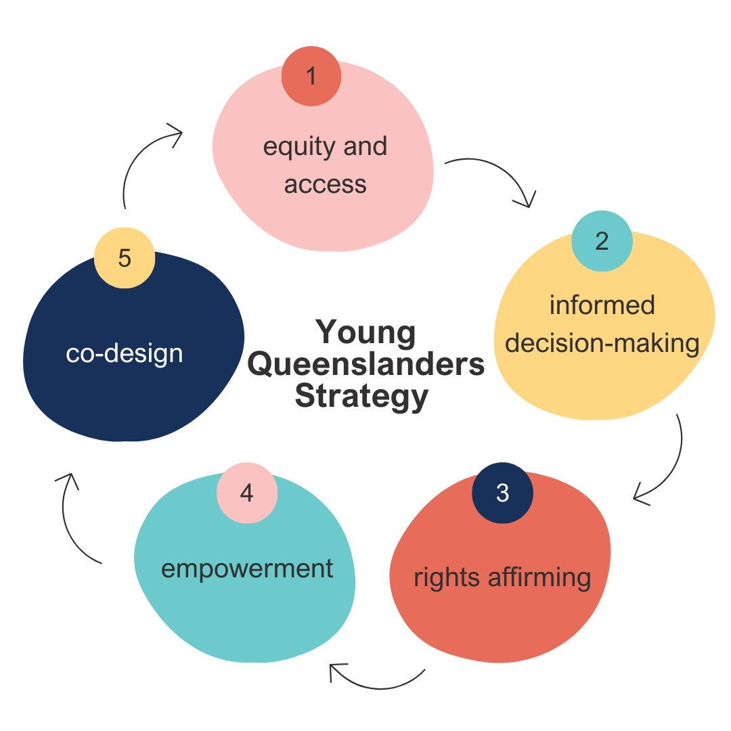

Young Queenslanders Strategy Action Plan 2024-2026
The 2024-2026 action plan builds on the foundations laid in the Young Queenslanders Strategy and includes targeted actions for the Queensland Government to create opportunities to empower young people on their individual pathways as they:
Participate in the world around them through exploration and positive influence.
Cultivate their futures supported by access to tailored opportunities that nurture their unique needs and interests.
Live their best lives empowered and equipped with the information, resources and support they need to get there.
Thrive in our communities knowing they are connected, celebrated and resilient.
The focus areas under these pathways were identified through consultation with young people and will guide the actions we take over the life of the Young Queenslanders Strategy to ensure our targeted activities are effective and continue to respond to the current and emerging needs of the cohort.
To help young people feel heard, we will also publish annual reports that showcase activities undertaken in the areas young people told us were the most important, and that may be built upon in later action plans.
Empowering young people is a collective responsibility, and we are committed to continued collaboration and meaningful engagement with young people, involved agencies, and the sector to ensure we are on the right path to achieving our vision.

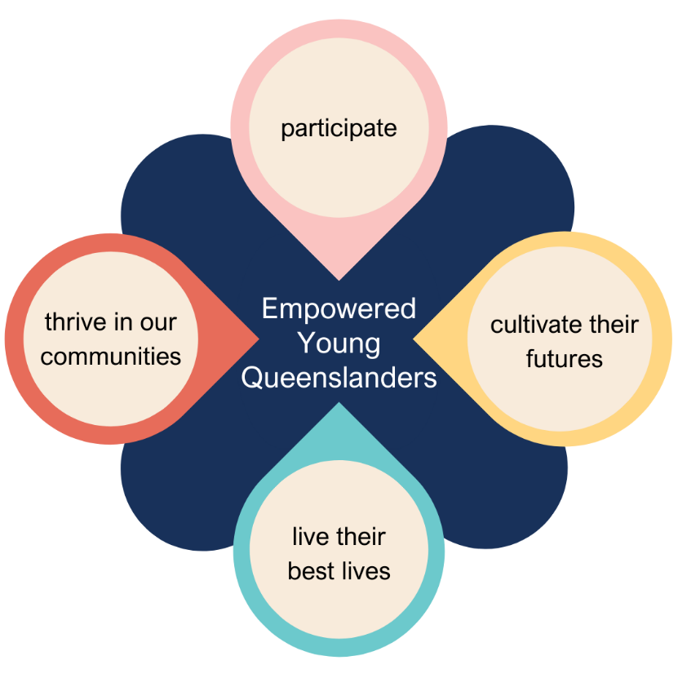

Glossary
The following glossary identifies an agency name, statutory authority which falls under a specific Queensland Government department, or a distinct office. These acronyms are used to determine responsibility for specific actions. Where more than one agency is responsible for the delivery of an action, the lead agency is identified as such.
- AQ: Arts Queensland, DTATSIPCA
- DAF: Department of Agriculture and Fisheries
- DCSSDS: Department of Child Safety, Seniors and Disability Services
- DoE: Department of Education
- DEC: Department of Energy and Climate
- DESBT: Department of Employment, Small Business and Training
- DESI: Department of Environment, Science and Innovation
- DHLGPPW: Department of Housing, Local Government, Planning and Public Works
- DJAG: Department of Justice and Attorney-General
- DPC: Department of the Premier and Cabinet
- DRDMW: Department of Regional Development, Manufacturing and Water
- DTATSIPCA: Department of Treaty, Aboriginal and Torres Strait Islander Partnerships, Communities and the Arts
- DTMR: Department of Transport and Main Roads
- DTS: Department of Tourism and Sport
- HWQld: Health and Wellbeing Queensland
- OfY: Office for Youth (Queensland)
- OIR: Office of Industrial Relations
- ORRQ: Office for Rural and Regional Queensland
- OfW: Office for Women
- PSC: Public Sector Commission
- QAGOMA: Queensland Art Gallery | Gallery of Modern Art, DTATSIPCA
- QFCC: Queensland Family and Child Commission

Participate
Young people participate in the world around them through exploration and positive influence.
Regardless of where they have come from or where they are going, young people should be provided with meaningful opportunities to participate in government decision making and to contribute to the development of their future through civic engagement.
This action plan seeks to provide multiple opportunities and mechanisms for young people to connect with government, contribute to civic life and learn about the formal systems which support them. These opportunities will be supported by building on the 2019 Youth Engagement Charter to co-design a best practice participation framework to ensure a consistent and responsive government approach.

Responsive government:
Young people are meaningfully consulted - and their voices are heard, valued, and reflected in the design and implementation of our programs, policies and services
- Action: Undertake targeted research on Aboriginal and Torres Strait Islander young males’ engagement with online gambling to better inform the design and delivery of effective gambling harm minimisation interventions.
Responsible Agency: DJAG

- Action: Engage young people through the LGBTQIA+ Alliance and the Pride in Our Communities LGBTQIA+ Strategy and Action Plan to lead and contribute to activities that promote and raise awareness of critical current and emerging issues for their communities.
Responsible Agency: DTATSIPCA

- Action: Co-design a whole-of-government Youth Participation Framework and Code of Practice to ensure that young people's views are heard, influence government policies and programs, and support their meaningful participation in decision-making across Queensland.
Responsible Agency: OfY

- Action: Enhance engagement with young people and align data collected through Speak OUT events with the strategic objectives of the Young Queenslanders Strategy, to facilitate more comprehensive and targeted information sharing across government to inform the development of youth policies, programs, and services.
Responsible Agency: OfY

- Action: Engage with young people to explore food system solutions for improved food security in remote Queensland Aboriginal and Torres Strait Islander Communities.
Responsible Agency: HWQld (lead agency), OfY

- Action: Support cross-government engagement to amplify the voices of young Queenslanders in key regional, rural, and remote areas, promote youth participation in government processes and decision-making, and support leadership development.
Responsible Agency: ORRQ (lead agency), OfY

- Action: Collect insights from young Queenslanders on their unique experiences with mental health to inform the development and implementation of Queensland’s Mental Health and Wellbeing Strategy and contribute to building a Queensland where everyone’s wellbeing is valued.
Responsible Agency: HWQld (lead agency), OfY

- Action: Involve young people in testing risk assessment tools and approaches for young people impacted by or using violence. The tools will support practitioners who work with young people and complement the existing victim-survivor focused Domestic and Family Violence Common Risk and Safety Framework.
Responsible Agency: DJAG (lead agency), OfY

Educational Programs:
Young people have opportunities to learn how the systems around them work in ways adaptive to their unique journey and lived experience
- Action: Promote regional community engagements, programs, think-tanks, workshops, and forums, to young people to increase participation.
Responsible Agency: DRDMW

Genuine participation, co-design and influence:
Young people are provided opportunities to participate in the design and implementation of government processes and are supported to effect meaningful change on their terms.
- Action: Explore the development of a Young Archivist Program.
Responsible Agency: QSA (lead agency), OfY

- Action: Establish a Students Advisory Group to provide advice on the design of services and programs.
Responsible Agency: SLQ

- Action: Support and encourage the participation of young people in place-based change including through positions on Local Leadership Groups, which are locally defined groups carrying cultural and community authority, trust, and credibility, representing people who live and work in and for the community.
Responsible Agency: DTATSIPCA

Participate: Hayes Butler – Youth Strategy Engagement Group
My name is Hayes, and I’m a 16-year-old member of the Youth Strategy Engagement Group (YSEG) living on the lands of the Jaggera and Turrbal people in Meanjiin/Brisbane.
The opportunity to contribute to this document is, I’m sure, an experience no one in the YSEG or FNYSEG will ever forget. Not only has being part of these groups empowered us to become further involved in different leadership initiatives, but it has also provided us with the special opportunity to draft a government strategy with the Department of Treaty, Aboriginal and Torres Strait Islander Partnerships, Communities and the Arts. To truly be able to design this document alongside the wonderful people in the Department was a special and unique opportunity. But it shouldn’t be. It’s only because of the hardworking people from the Office for Youth and the Department that we, on behalf of the roughly 900,000 young people in Queensland, could co-design a strategy directly addressing the issues we face. A main pillar of democratic governance is that governments fundamentally govern for the people. So, when governments formulate policy, they must consult their constituents. And yet, in consultations, young people are consistently forgotten.
The fact is, young people are vulnerable. We leave home at a larger disadvantage than any other age group. And that means we require government services to make ends meet. Income support and education are some of the most important services that governments provide. Given the fact that young people use these services at a higher rate than any other age bracket, and given the fact that only 18-year-olds and older are given a basic say in policy as voters (a divide that excludes almost all school students), governments need to start thinking about how best to enfranchise young people so the services they rely on are working to ensure effective delivery and the best possible outcomes. Getting key stakeholders in the room to discuss the best possible approach to policy implementation should be the chief consideration for all governments that want to deliver outcomes most efficiently. It’s universally accepted that good policy isn’t created in a vacuum, it’s formed in consultation with the community. The founding principle of the YSEG is that no one knows young people like other young people. We don’t want policy made for us; we want it made with us.
There is no compelling reason for governments to not engage young people in the conversation, particularly when the conversation has become more pertinent to us than ever before. Young people have been talking about issues like housing affordability and climate change since the last youth strategy, almost 7 years ago (at time of writing). The trend is clear - because young people are more vulnerable, we’re ahead of the curve on the major issues, so we need to be listened to. The great opportunity of a co-designed strategy like this is that young people have been able to lead the conversation and have a direct say in how this strategy is formed, right down to specific wording and grammatical choices. This strategy as a standalone document is incredible because it represents years of work with both the government and Queensland’s youth. More than that, though, this strategy’s conception should serve as a blueprint for government strategies going forward. No facet of government decision-making doesn’t affect young people. We are a stakeholder as much as anyone else. It’s high time our government sees that and gives us the voice we need and deserve.

Cultivate their futures
Young people cultivate their futures supported by access to tailored opportunities that nurture their unique needs and interests.
Supporting creativity and innovation are ways we can connect with each other that lead to positive social and civic engagement outcomes. Encouraging economic participation and providing opportunities for young people to elevate their skills and build interest in traditional and emerging industries will provide opportunities for young people to find careers they are passionate about.
Work that is meaningful and that makes young people feel valued, respected, and properly rewarded for their time and effort sets them up to succeed in and out of the workplace. Through this action plan, young Queenslanders will be supported to participate in the workforce and through school-to-work transitions and be empowered with high-quality information about employment rights to support diverse careers.

Careers and Employment
Young people are equipped with the tools and skills required to build the careers they want in the fields that interest them
- Action: Fund innovative partnerships, through programs such as the Workforce Connect Fund, to overcome barriers to employment for young people and increase opportunities for priority groups by driving systemic, industry-wide change in relation to attraction, retention, and participation challenges within workforces.
Responsible Agency: DESBT

- Action: Through the Good people, Good jobs: Queensland Workforce Strategy 2022–2032, facilitate the delivery of a suite of initiatives to support employment and training outcomes for young people.
Responsible Agency: DESBT

- Action: Develop online resources and support for employers to create inclusive and diverse workplaces, including for young people.
Responsible Agency: DESBT (lead agency), OfY

- Action: Deliver National Science Week events and activities highlighting the great science happening in Queensland and the career opportunities in STEM.
Responsible Agency: DESI

- Action: Introduce quantum technology skill development into schools and TAFE by establishing a Queensland Quantum Academy, which will be a partnership between Government, industry and universities.
Responsible Agency: DESI
- Action: Deliver the Engaging Science Grants program to inspire young people to consider STEM education and careers.
Responsible Agency: DESI

- Action: Develop the First Nations Economic Strategy to support the delivery of skills, training and development opportunities, employment/career pathways, and support for entrepreneurship and business development for First Nations young people across Queensland.
Responsible Agency: DTATSIPCA

- Action: Pilot an additional traineeship position following the Queensland Indigenous Youth Leadership Program through the Queensland Office for Youth to enable employment and training pathways for young Queenslanders to develop and progress their careers in the Queensland Government.
Responsible Agency: OfY

- Action: Implement a new model for non-frontline graduate programs which provide a holistic and consistent approach to launch and support meaningful public sector careers.
Responsible Agency: PSC

Business and Entrepreneurship
Young people are equipped with information and access to expertise and opportunities to build and grow businesses and entrepreneurial ventures
- Action: Promote opportunities for young Queensland Female Founders with innovative businesses to participate in programs successfully funded through key initiatives under the Backing Female Founders program.
Responsible Agency: DESI

- Action: Develop resources that assist young people to access and develop applications for government grants and funding opportunities, and advocate for youth funding rounds.
Responsible Agency: OfY

Education and Training
Young people are supported by inclusive and effective education and training systems that inspire learning and growth, and foster positive transitions from school to work
- Action: Expansion of First Nations Attendance and Engagement programs, which support students to attend school, engage in learning and complete Year 12.
Responsible Agency: DoE

- Action: Implement the Career Education Development Program for students in years 7 to 10 to provide practical and quality information to students to support them in making informed career choices.
Responsible Agency: DoE

- Action: Provide professional development to school leaders on creating inclusive teaching and learning environments.
Responsible Agency: DoE

- Action: Deliver STEM in state schools through the implementation of Version 9 of the Australian Curriculum.
Responsible Agency: DoE

- Action: Develop and implement a statewide teacher career and education capability development program to increase teacher capability and confidence to deliver career education in schools.
Responsible Agency: DoE

- Action: Through Equity and Excellence: realising the potential of every student, deliver the ‘On track for Success’ system initiative for junior secondary, which focuses on engaging students in their learning, including supporting wellbeing, education, and partnerships to enhance student outcomes in Years 7-9.
Responsible Agency: DoE

- Action: Make available quality training pathways that give young people the skills to start out on their careers through the implementation of the new Good Jobs, Great Training: Queensland Skills Strategy 2024-2028
Responsible Agency: DESBT

- Action: Support the flexible provision of Certificate II in Horticulture / Conservation and Ecosystem Management, which allows delivery of the qualifications in schools and on country.
Responsible Agency: DESI

- Action: Deliver the Junior Ranger Program which aims to empower Indigenous youth through education, conservation, and cultural engagement while improving student attendance among Indigenous students and creating multiple pathways for work post-program.
Responsible Agency: DESI

- Action: Provide engaging teacher professional development opportunities in Brisbane and regional Queensland to build capability in inspiring learning through libraries.
Responsible Agency: SLQ

Building Creative and Innovative Generational Futures
Young people are enabled to unleash their creative potential to contribute to the continuous evolution and innovation necessary for building a better Queensland
- Action: Invest in schools touring services to ensure that school students in rural and remote Queensland communities have access to engaging high quality, inspiring and curriculum-connected arts and cultural experiences.
Responsible Agency: AQ

- Action: Pilot an arts-led youth justice initiative in Townsville, a partnership between Arts Queensland and the Department of Youth Justice’s Transition 2 Success program, to strengthen outcomes and improve future pathways for young people who have been involved with the youth justice system.
Responsible Agency: AQ

- Action: Support paid Industry Placements for young people in arts and cultural organisations, growing career pathways and employment in Queensland ‘s creative and cultural workforce.
Responsible Agency: AQ

- Action: Support tailored training initiatives and paid Industry Internships for school leavers, university graduates and/or emerging practitioners to develop career pathways, project credits and employment in Queensland’s screen, games and online media industries.
Responsible Agency: SQ

- Action: Investigate opportunities that support young people to engage in renewable energy careers, projects and training, in ways that are of interest and importance to them. This includes exploring youth-focused events forged in partnership with industry leaders and academic institutions to ensure the development of tailored pathways that empower and equip young people to thrive in the renewable energy sector.
Responsible Agency: DEC

- Action: Support a range of partnerships through Advance Queensland to deliver youth innovation programs during school holidays and throughout the year at The Precinct in Brisbane and regional innovation hubs across the State. This includes immersion in emerging technologies, STEM education and entrepreneurship skills and capability building opportunities.
Responsible Agency: DESI

- Action: Promote and support youth volunteering as part of the development of a Queensland volunteering strategy.
Responsible Agency: DTATSIPCA

- Action: Provide a range of programs onsite, online and in regional Queensland to connect young people with art and artists.
Responsible Agency: QAGOMA

- Action: Deliver high quality programs that link young people in Brisbane and regional Queensland with collections and creative experiences.
Responsible Agency: SLQ

Cultivate their futures: Lexi Croce

Lexi Croce, a Moranbah State High School student, possesses a deep understanding of the resource sector that extends beyond her local community. During her secondary school journey, Lexi actively participated in a range of activities offered by the Queensland Minerals and Energy Academy (QMEA) which forms part of the Queensland Government’s Gateway to Industry Schools Program (GISP). These activities included the Beakers.Bots.Build program in Year 9, STEM Unearthed in Year 10, and Tradies for a Day in Year 10.
Lexi 's exceptional aptitude for STEM subjects shone through as her team of six students clinched the top spot at the 2022 ARISE STEM Innovation Experience Queensland Regional Showcase. Subsequently, her team advanced to the STEM Innovation Experience National Final at the University of South Australia.
Lexi’s engagement extends beyond the classroom. As a BHP Mitsubishi Alliance Youth Advisory Council member, she provided valuable insights and perspectives to Smart Transformations, contributing to the sustainable development of the Dysart and Moranbah communities. This role granted Lexi firsthand experience, including a tour of Goonyella Riverside Mine, where she gained insights into the role of autonomous technologies in the resource sector. She also toured the Integrated Remote Operations Centre in Brisbane, further deepening her industry knowledge. Lexi 's initiative led her to complete a 10-day work experience stint at Peak Downs Mine, where she gained a thorough understanding of the roles of electrical engineers and other professionals.
As Lexi embarks on her Year 12 journey, she assumes the prestigious role of School Captain, poised to provide leadership to her school community. In her final year of schooling, Lexi is determined to solidify her post-school career path as an electrical engineer. She will participate in the QMEA/Women in Mining and Resources Queensland (WIMARQ) Girls in Resources Leadership Skills Mentoring Program for six months to achieve this goal. During this program, Lexi will be partnered with a mentor from the resource sector.
Lexi's journey with the QMEA has led to her recognition as a finalist in the QMEA/WIMARQ Exceptional Female Student of the Year award, a testament to her remarkable achievements.
Industry-school partnerships like the QMEA and the eleven other industry programs run through the GISP provide thousands of young Queenslanders with a practical taste for careers in local industries. The Queensland Workforce Strategy focuses on strengthening these partnerships to support successful pathways into employment or TAFE/university to help young Queenslanders into good jobs and rewarding careers.
Lexi’s inspiring story embodies the Queensland Workforce Strategy's commitment to creating a strong and adaptable workforce that can attract new talent and support regional investment. Her story is a shining example of how educational initiatives and industry collaboration can shape the workforce of the future in Queensland.

Live their best lives
Young people are enabled to live their best lives empowered and equipped with the information, resources and support they need to get there.
Strengthening connections to the physical environments of young people and our communities provides consistency and stability, laying the foundation for them to explore and interact with the world around them as they grow and change.
Having access to safe and affordable housing, appropriate mental and physical healthcare, trusted information and being equipped with relevant life skills are fundamental requirements for positive whole-of-life outcomes for young Queenslanders.
Young people have told us they want to feel safe and valued in their communities, for their identities and histories to be respected and their needs understood and addressed. The Queensland Government takes young people’s safety seriously and is putting in place a framework to ensure all young people can thrive, regardless of their identities or lived experience.

Access to information
Young people have access to trusted information and to the supports and services they need, when they need them
- Action: Co-design a series of online resources, including for life skills, to provide easier access to trusted information and advice for young people, developed by young people.
Responsible Agency: OfY

Health and wellbeing
Young people are supported to achieve optimum levels of mental, physical and spiritual health and wellbeing
- Action: Re-develop and strengthen the Department of Education’s Alcohol and Other Drugs education program to include a focus on vaping.
Responsible Agency: DoE

- Action: Explore opportunities to increase young people’s accessibility to and voice in sport and recreation participation and talent pathways.
Responsible Agency: DTS

- Action: Promote community-led, local health initiatives delivered for young people across the ConnectingQ platform and network.
Responsible Agency: HWQld

- Action: Deliver a youth mental health campaign to promote wellbeing and boost awareness of mental illness.
Responsible Agency: QH

- Action: Implement new initiatives to improve health outcomes for young women and girls through the Queensland Women and Girls’ Health Strategy 2032. This strategy includes a focus on priority communities including First Nations women and girls, culturally and linguistically diverse women and girls, women and girls with disability, members of LGBTIQ+ communities, women and girls living in rural and remote areas and women and girls in contact with the justice system.
Responsible Agency: QH

- Action: Implement recommendations from the Parliamentary Inquiry into Reducing Rates of E-cigarette use, including:
- Co-design, pilot and evaluate a nicotine dependency support program for Queensland school students aged 12 years and older.
- Identify nicotine dependency services to support young people to quit vaping and or smoking.
- Provide training to increase the engagement skills of Quitline telephone counsellors to support young people to quit vaping and/or tobacco smoking.
Responsible Agency: QH

- Action: Implement research and public messaging to reduce harm from vaping and to understand and modify influences, barriers and enablers for young people trying, and quitting vaping.
Responsible Agency: QH

- Action: Optimise and grow state-funded comprehensive, culturally safe treatment, harm reduction, care and support for young people experiencing mental ill health, problematic alcohol and other drug use, and mental health crisis, including through:
- Establishing new and enhancing existing early psychosis services for young people aged 12 to 25 years across Queensland to support hospital and health services in providing timely assessment and evidence-based care and treatment.
- A new alcohol and other drugs residential (10-bed) and non-residential treatment service for young people in North Queensland based in Cairns.
- Providing clinical in-reach into all Headspace centres across Queensland to increase access to multidisciplinary team care, enhance integration and streamline transition of care between headspace and state-funded specialist mental health, alcohol and other drug services for young people aged 12 to 25 years.
Responsible Agency: QH

- Action: Optimise and increase capacity within health to provide safe, quality care for youth. This will be actioned through:
- Formulation of an Adolescent and Young Adult Medical Services Framework to guide QH service improvement in youth healthcare.
- Statewide health professional education in paediatric and adult medical services to embed evidence and increase service capacity in healthcare provision to 12-to25-year-olds.
Responsible Agency: QH

Home and community
Young people are safe and secure in their physical locations, and feel empowered to thrive independently no matter where they are or where they’re heading
- Action: Deliver rental law reform to strengthen renters’ rights and stabilise rents, which will help support young people to obtain and sustain tenancies in the private rental market.
Responsible Agency: DHLGPPW

- Action: Deliver new and improved digital resources for young people and their support networks to:
- Access housing, homelessness and domestic, family and sexual violence services early.
- Learn how to secure and sustain tenancies in the private rental market.
- Plan pathways to homeownership through existing state, federal and other supports.
Responsible Agency: DHLGPPW (lead agency), OfY, DCSSDS

- Action: Pilot an innovative family reunification service for children and young people aged 12 to 15 years to reduce the risk of homelessness.
Responsible Agency: DCSSDS, DHLGPPW

- Action: Establish a service for young pregnant and parenting women to enhance their independent living and parenting skills and reduce the likelihood of child safety involvement.
Responsible Agency: DCSSDS

Life Skills
Young people are equipped with real-world life skills that help them to succeed as they transition into adulthood and onwards
- Action: Conduct targeted gambling awareness campaigns, including a specific sports betting campaign to address the normalisation of betting in sport and to raise awareness among young people about the potential risk and harm from gambling and strategies to mitigate this risk.
Responsible Agency: DCSSDS

- Action: Deliver a new youth gambling education program and resources to educate young people and their families of the potential risk and harm from gambling.
Responsible Agency: DJAG

- Action: Expand the BuySmart program, helping to grow young peoples’ consumer and financial literacy skills through the development and promotion of youth-focused resources.
Responsible Agency: DJAG (lead agency), OfY

Live their best lives: Isaac Campbell
Moreton ATSICHS Deadly Choices team delivered 22 DC Healthy Lifestyle programs across the Moreton Bay region in Term 1, 2024. One of those programs was facilitated at Mango Hill Secondary College in North Lakes where we have a very familiar student to the DC programs. Isaac Campbell is a student in Year 7 now and has been involved in the Deadly Choices Healthy Lifestyle programs since 2019 as a student at Bounty Boulevard State School. Isaac has also participated in the Junior Murri Carnival every year with the Moreton ATSICHS Deadly Choices team, and this year will be his first year taking part in the Queensland Murri Carnival in U14’s.
Isaac has always been a heavily involved student within our programs. In 2019 when Isaac began his journey with Deadly Choices, he was consistent and on-time to every weekly session at his school. Isaac completed and graduated from the Junior Healthy Lifestyle, Junior Good Quick Tukka and Junior Tobacco programs at Bounty Boulevard. This is where Isaac built a good rapport with the Moreton ATSICHS Deadly Choices staff members. Isaac became a familiar face at school and DC Events. Isaac always shows good leadership, very supportive of staff and wanting to help, engaging in the DC program content, and participating in the DC activities/ice breakers.
Throughout Isaac’s journey with us, we have built a strong relationship with Isaac’s younger brother Jai Campbell who has also completed and graduated all DC Healthy Lifestyle programs and attends our Moreton ATSICHS Deadly Choices Junior Murri Carnivals every year. We have remained close with both Campbell boys and their mum, Kaitlin Howard who is always supportive of the boy’s engagement and attendance within Deadly Choices. Isaac says he has learnt a lot throughout his participation with Deadly Choices and has thoroughly enjoyed his first term in High School completing and graduating from the Senior Healthy Lifestyle program with DC Program Officer, Quinlyn Cannon.
Isaac has identified that there are other students his age or people he knows who smoke and/or vape but due to his learnings with Deadly Choices, he is aware and confident that this is not something he is interested in or will uptake. He says he has learnt a bit about online safety this term and he felt it was relevant as he has a phone and plays his PS5 online. He feels he knows how to be safe and is confident in speaking to his DC Officer or mum if he needs any reassurance with online safety.
Isaac mentions how he hopes to see Deadly Choices continue so other kids get the same experiences and outcomes he’s had while being part of Deadly Choices. Isaac says he’s been to NRL Broncos and Dolphins games at Suncorp Stadium, he’s had the opportunity to play before the NRL games, be a part of the NRL Guard of Honor for the players to run onto the field, and he attended the 2024 reward day “Deadly Day Out” at Wet N Wild on the Gold Coast in January for good leadership. He says he’s had a lot of fun and he’s met different people in which he's formed genuine friendships with.
Deadly Choices have loved watching Isaac come through the programs, seen him thrive through his schooling years, take up sports and feedback his learnings to his mum. He’s still learning and enjoying the Senior Programs and we love and enjoy seeing the growth in our students, and Isaac has been the perfect example for Deadly Choices, and we look forward to the future with Isaac.
Deadly Choices, funded by the Queensland Government through Health and Wellbeing Queensland, supports and empowers Aboriginal and Torres Strait Islander peoples to make healthy choices for themselves and their families. To find out more about the program visit https://deadlychoices.com.au/

Thrive in our communities
Young people thrive in our communities knowing they are connected, celebrated and resilient.
The Queensland Government is committed to acting consistently and transparently with what the science indicates around climate change and building systems which consider the long-term impacts on community and Country to ensure a liveable future for current and future generations.

Community spaces provide a place for young people to hang out with their mates, learn new skills, complete homework, or even speak with a trusted adult.

Science, climate change and world issues
Young people drive innovative and positive change in their communities and feel equipped to thrive in an ever-changing world
- Action: Explore opportunities for young people to engage with the AgTech innovation ecosystem through implementation of the Queensland AgTech Roadmap 2023-2028, connecting with Office for Youth-led programs such as the Youth Research Grants to support career pathways and innovation.
Responsible Agency: DAF (lead agency), OfY

- Action: Investigate opportunities to improve young people’s awareness of renewable energy.
Responsible Agency: DEC

Connection
Young people have meaningful opportunities to drive change in the community, share learnings and strengthen relationships
- Action: Improve the experiences of young people who access Neighbourhood Centres, through centres enhancing their understanding of the needs of young people, informed by the collection and utilisation of data, and engagement with local youth service networks.
Responsible Agency: DTATSIPCA

- Action: Build a mentoring and development network with members of Queensland’s youth councils to leverage networks and enhance data collection regarding young people’s top issues and priorities in Queensland.
Responsible Agency: OfY

Transport
Young people are educated about road safety, feel confident on our roads, and have improved access to affordable, reliable and safe transport options
- Action: Encourage more young people to walk and ride a bicycle more often in our communities through delivering initiatives under the Queensland Cycling Strategy and Queensland Walking Strategy.
Responsible Agency: DTMR

Celebrating culture and diversity
Young people from diverse backgrounds are celebrated and encouraged to thrive, with their unique stories, abilities and perspectives recognised and embraced
- Action: Explore opportunities to engage with young people with disability and young carers in relation to disability reforms in Queensland including in relation to the findings of the National Disability Insurance Scheme Review and Royal Commission into Violence, Abuse and Neglect of People with Disability.
Responsible Agency: DCSSDS

- Action: Through the Queensland Women’s Strategy 2022-27, continue to work toward achieving gender equality and lifting opportunities for young women and girls, particularly improving their economic security and opportunity.
Responsible Agency: OfW

- Action: Increase access to STEM education for First Nations young people through the Deadly Coders project to support access to the coding platform for up to 4,000 students across Queensland.
Responsible Agency: DESI (lead agency), DTMR

- Action: Increase youth participation within First Nations Council areas and partnerships with local First Nations communities including with Local Decision Making Bodies.
Responsible Agency: DTATSIPCA

- Action: Reshape the Queensland Indigenous Youth Leadership Strategy through meaningful co-design with young people and their communities that empowers them to facilitate change.
Responsible Agency: OfY

- Action: Deliver enhancements to the Queensland Indigenous Youth Leadership Program to support participants pre and post course, build the alumni network, mentorship, connections to business and industry, and support young people to engage in Truth and Treaty including through the development of resources.
Responsible Agency: OfY

- Action: Through the Putting Queensland Kids First initiative, co-design, deliver, and formally evaluate a pilot leadership and development program that focuses on young First Nations parents, equipping them with the tools they need to change the narrative and scaffold their children to become future leaders in their community.
Responsible Agency: OfY (lead agency), DPC

- Action: Partner with Aboriginal and Torres Strait Islander Community Health Service to provide Young, Black and Proud Scholarships to support First Nations young people to pursue their aspirations. Young people aged 25 or younger can apply for scholarships of up to $2,000.
Responsible Agency: QFCC

Thrive in our communities: Charles Hazelton
Hej; Halò; Yiradhu Marang; Kia Ora; Hello.
My name is Charles, and I am a 23-year-old Wiradjuri Man of Swedish descent, born and raised on the lands of the Yugambeh people of South-East Queensland. I am also a descendent of the Māori People of Aotearoa, New Zealand. As I walk through life, it is with the recognition and celebration of these cultures and the impact that they have had on my existence, thus far.
In July of 2023, I was heavily encouraged to apply for the Queensland Indigenous Youth Leadership Program (QIYLP) by a First Nations Liaison Officer at Griffith University. At the time of application, I had no idea if I would even be accepted, nor did I know just how much this program was going to up-end my life in the best ways possible. During QIYLP, I learned of my capacity for leadership. In all honesty, it took me by surprise. I had never thought of myself as a role-model or imagined that I would be someone that others would look to in a time of need.
I am now in my second year of a Bachelor of Health Science at Griffith University, and, following completion of my undergraduate degree, I intend to continue through to the Doctor of Medicine program. I cannot begin to imagine where my career will take me in the future, but with the support I have received from the network I built during QIYLP, and the institutions that have taken an interest since, I am renewed and, frankly, quite impatient to see how much of a positive impact I can make.
On Day 1 of QIYLP, I wondered what I had gotten myself into and whether I deserved to be there at all. By the end of the program, I had spoken more in that week than I had in previous months, combined. Fast forward to now, I can say that keeping me quiet is much more difficult. So difficult, in fact, that I have since used my voice to provide mentorship and guidance to at-risk and LGBTQIA+ Youth and am looking further into how I can use my place in this world to help those in similar situations to myself, prior to the impact of QIYLP.
Doors have opened for me since QIYLP; Some were locked, others were just a little jammed, but I have no intention of closing them behind me. I am using my voice to do my part as a member of the First Nations Youth Strategy Engagement Group for the betterment of my community and to see it through for a better future for all Queenslanders.
I am very proud of what I have accomplished since attending QIYLP. The program was instrumental in changing the way that I viewed myself and my contributions to my community; That I am worthy and that my impact is felt. My hope is that QIYLP continues to be the instrument for others as it has been for me. It’s a high expectation program, but, Oh Boy, does it deliver.

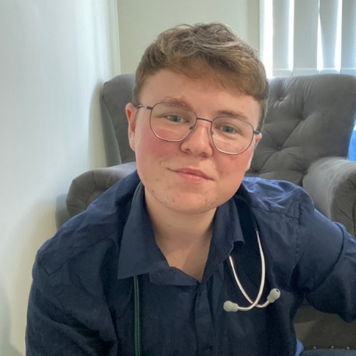

Next steps
This 2024-2026 action plan is the first of several and will act as a valuable stepping stone towards achieving our vision of a Queensland where young people are empowered to actively participate, cultivate their futures, live their best lives, and thrive in our communities.
Through the first action plan, we work towards increasing participation and create opportunities to make meaningful steps towards change by including targeted actions that are aimed at making tangible improvements in the areas young people told us are important.
Young people have called for real and measurable change, and we are committed to ongoing monitoring on the progress of these actions to evaluate their impact and inform the development of future action plans. We will release annual highlights reports that show the Queensland Government’s progress on this important work.
We will continue to collaborate with young people to ensure our actions remain relevant and respond to their emerging needs and will support their active involvement in implementation through meaningful, inclusive, and impactful co-design processes – not only for this first action plan, but for all future action plans.
As part of our commitment to Queensland’s young people we'll release periodic Youth Sentiment Snapshots, capturing a point-in-time view of our young people’s issues, hopes, desires and aspirations for an enhanced Queensland. The creation of these reports will involve an active, ongoing collaboration with diverse young people from many backgrounds, stories and lived experiences. This process will unfold throughout the lifespan of the Strategy and associated action plans, ensuring our enduring commitment for young people to be involved every step of the way.

