Guidelines for the discovery, handling, and management of human remains

Table of contents
Guidelines for the discovery, handling, and management of human remains 1
Guiding principle 1
Desired outcomes 1
Legislative framework 1
Criminal Code Act 1899 1
Coroners Act 2003 1
Aboriginal Cultural Heritage Act 2003 and Torres Strait Islander Cultural Heritage Act 2003 1
Procedures for dealing with the discovery of Aboriginal and Torres Strait Islander human remains 2
Procedure for dealing with the discovery of human remains 3
Explanation of procedures 4
Further information 4

Guidelines for the discovery, handling, and management of human remains
This guideline has been developed under the provisions of the Aboriginal Cultural Heritage Act 2003 and the Torres Strait Islander Cultural Heritage Act 2003 (the Acts).
If you find bones and suspect they are human, it is essential that you do not disturb them. You must report the findings to the Queensland Police Service as soon as possible. The Police will determine if the remains represent a crime scene. If it is established that the remains are not a crime scene and the Coroner is satisfied that the remains are ancestral Aboriginal or Torres Strait Islander human remains, the procedures in this guideline will apply.

Guiding principle
Aboriginal or Torres Strait Islander people who have traditional or familial links with ancestral human remains are the owners of those remains.

Desired outcomes
This guideline has a number of desired outcomes: -
• While natural or human processes can inadvertently expose Aboriginal or Torres Strait Islander human remains, all attempts will be made to limit further disturbance.
• If further investigation and disturbance is required, procedures are in place for the proper handling of such human remains.
• All such procedures are sensitive to the wishes of the Aboriginal or Torres Strait Islander owners of the human remains.

Legislative framework

Criminal Code Act 1899
Under the Criminal Code Act 1899, it is an offence to improperly or indecently interfere with a human body or human remains, whether buried or not. An offence under this provision can result in imprisonment of up to five years.

Coroners Act 2003
The Coroners Act 2003 provides that when human remains are located, it is the duty of the person who found the remains to report the findings to a Police Officer or Coroner. The Coroner will start an investigation, and if it is found that the remains are Aboriginal or Torres Strait Islander traditional burial remains, the investigation must stop. Where this occurs, and the human remains have been removed from the area where they were found, the Coroner will authorise the release of the human remains to the Minister responsible for administering the Acts.

Aboriginal Cultural Heritage Act 2003 and Torres Strait Islander Cultural Heritage Act 2003
Pursuant to the Acts, Aboriginal and Torres Strait Islander human remains
- includes burial objects and associated material; but
- does not include human remains —
(i) buried under the authority of the law of Queensland or another State; or
(ii) in or from a place recognised as a burial ground for interment of human remains buried under the authority of the law of Queensland or another State.

Under the Acts, Aboriginal or Torres Strait Islander people who have a traditional or familial link with Aboriginal or Torres Strait Islander human remains are the owners of those remains, regardless of who may have owned them before commencement of the Acts.
The Acts provide that where Aboriginal or Torres Strait Islander human remains are in the custody of the State, the owners of the human remains may at any time ask the State to continue to be the custodian of those remains or return the human remains to them.
If a person, other than the State, has in their possession Aboriginal or Torres Strait Islander human remains to which they do not have traditional or familial links, then the person must take all reasonable steps to ensure that the human remains are taken into the custody of the chief executive administering the Acts as soon as practicable. Penalties apply if a person fails to do so.
If a person knows of the existence and location of Aboriginal or Torres Strait Islander human remains and is not the owner of those remains, the person must as soon as practicable (and after advising the Police or Coroner) advise the chief executive of the remains. Penalties apply if a person fails to do so.

Procedures for dealing with the discovery of Aboriginal and Torres Strait Islander human remains
In all cases when human remains are located it is important to remember:
• The discovery of any human remains must be reported to the Police as soon as possible.
• It is an offence to interfere with a human body or human remains, whether buried or not.
The Police or Coroner must be advised of the presence of any human remains. An appropriate officer will then establish the area as a potential crime scene.
Police will undertake appropriate scientific or other procedures to assist the Coroner in making a determination about the human remains.
If the human remains are thought to be neither Aboriginal nor Torres Strait Islander, related to criminal activity, or are of doubtful determination, the Police may remove the remains for further analysis.
If the human remains are determined to be ancestral human remains without the need for removal, the relevant Traditional Owners of the remains will be responsible for their management.
In cases where human remains are removed by Police and subsequently determined by the Coroner to be of Aboriginal or Torres Strait Islander origin, the remains will be released to the Minister responsible for administering the Acts.
If this occurs, the Department of Treaty, Aboriginal and Torres Strait Islander Partnerships, Communities and the Arts is responsible for coordinating the return of the remains to the relevant Traditional Owners.

Procedure for dealing with the discovery of human remains
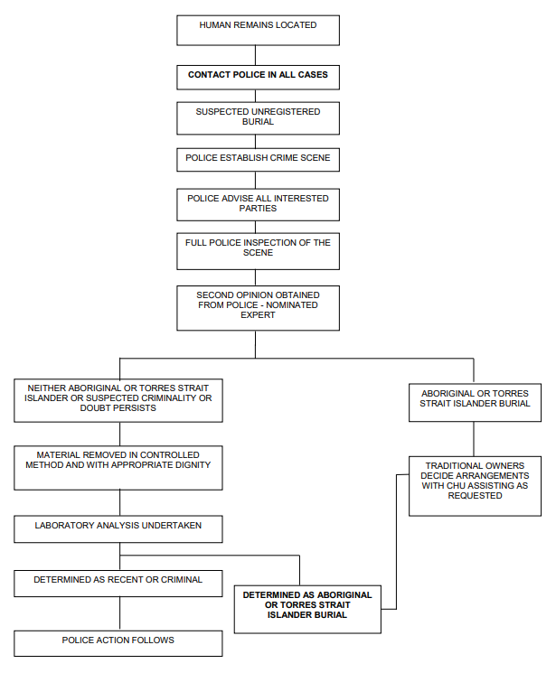

Explanation of procedures
Police Officers maintain authority and responsibility for a potential crime scene at all times. Police are responsible for forensic analysis and may seek advice from suitably qualified experts. Digital images may be sent to the relevant experts for an opinion to avoid the removal of the remains. Advice on handling may be sought from appropriate sources.

Further information
For further information, contact the Site Registrar.
Cultural Heritage Unit
Phone: 1300 378 401
Email: cultural.heritage@dsdsatsip.qld.gov.au

Visit the departmental website: https://www.qld.gov.au/firstnations/environment-land-use-native-title/cultural-heritage/human-remains

Aboriginal Cultural Heritage Act 2003 schedule 2; Torres Strait Islander Cultural Heritage Act 2003 schedule 2.

